Engaging with Intolerance

Newbold College, Binfield RG42 4AN 10:00-16:00, 25 October 2018

Conference opened by SEEFF Chair Bede Gerard who introduced the Chair of the Conference Margaret Lenton who gave a short brief about the essence of the conference: How do we engage with intolerance at all levels. She then introduced the Newbold College Principal, Dr John Baildam who gave us a potted history of the college, which started in 1901 as a training college for ministers in Watford, then moved to Binfield in 1946. The main building dates back to 1864. The college is now a campus like a small university accommodating around 200 students from many nationalities. They still train pastors for 7th Day Adventists but welcomes people of any or no faith as long as they accept the lifestyle.

Morning Session: Engaging with intolerance; how does the individual engage; how does the government engage
The first speaker of the morning Abu Ahmed, Home Office Prevent Officer said that the intolerance was growing in lots of different parts of the world, feeding around the world. Also people in the UK were trying to spread hatred. Today’s fixation seemed to be with Muslims rather than in past with black people and ethnic minorities. Stressing that there is need for complex balance between security and freedom of speech and also academic freedom, Ahmed informed us on Government’s Prevent Strategy and Integration Strategy. He also mentioned that there were Anti-semitism and Islamophobia issues for a long while, hence the need for Prevent duty which is in now in legislation.

Naheem Bashir, Slough Brough Council’s Prevent Lead said that intolerance went back for ever, e.g. N.Ireland Catholics. Stating that Prevent was 10yr old, Bashir stressed that it was against terrorism that includes far right as well as (some) Muslims. Unfortunately most young people look at 9/11 rather than N.Ireland, he added. Prevent is a safeguarding measure to offer support for vulnerable individuals, who are now brainwashed (not radicalised) via media rather than in physical meeting. Prevent is to safeguard individuals and it does not deal with hate crime, Bashir added.

Mark Spencer, Chief Inspector - Deputy LPA Commander Thames Valley Police reported on the police involvement in Prevent. He mentioned that in the old days there was racism in police force, but now they have mixed faith/race marriages. Although we’re neither getting better nor worse but are getting more transparency and nasty individual conversations now becomes more global and it is easier to tackle with this kind of hate crime.

Jonathan Romain, Rabbi of Maidenhead Synagogue talked about his Jewish background and used to being a minority, whereas others are having to realign. He said “An anti-semite is someone who dislikes Jews more than necessary.” Stressing that Fear and bigotry was part of human condition, Rabbi Romain added that intolerance included differences within individual faiths. He also said that there has always been antisemitic elements in all parties but recently these have been allowed to rise to the fore in Labour.

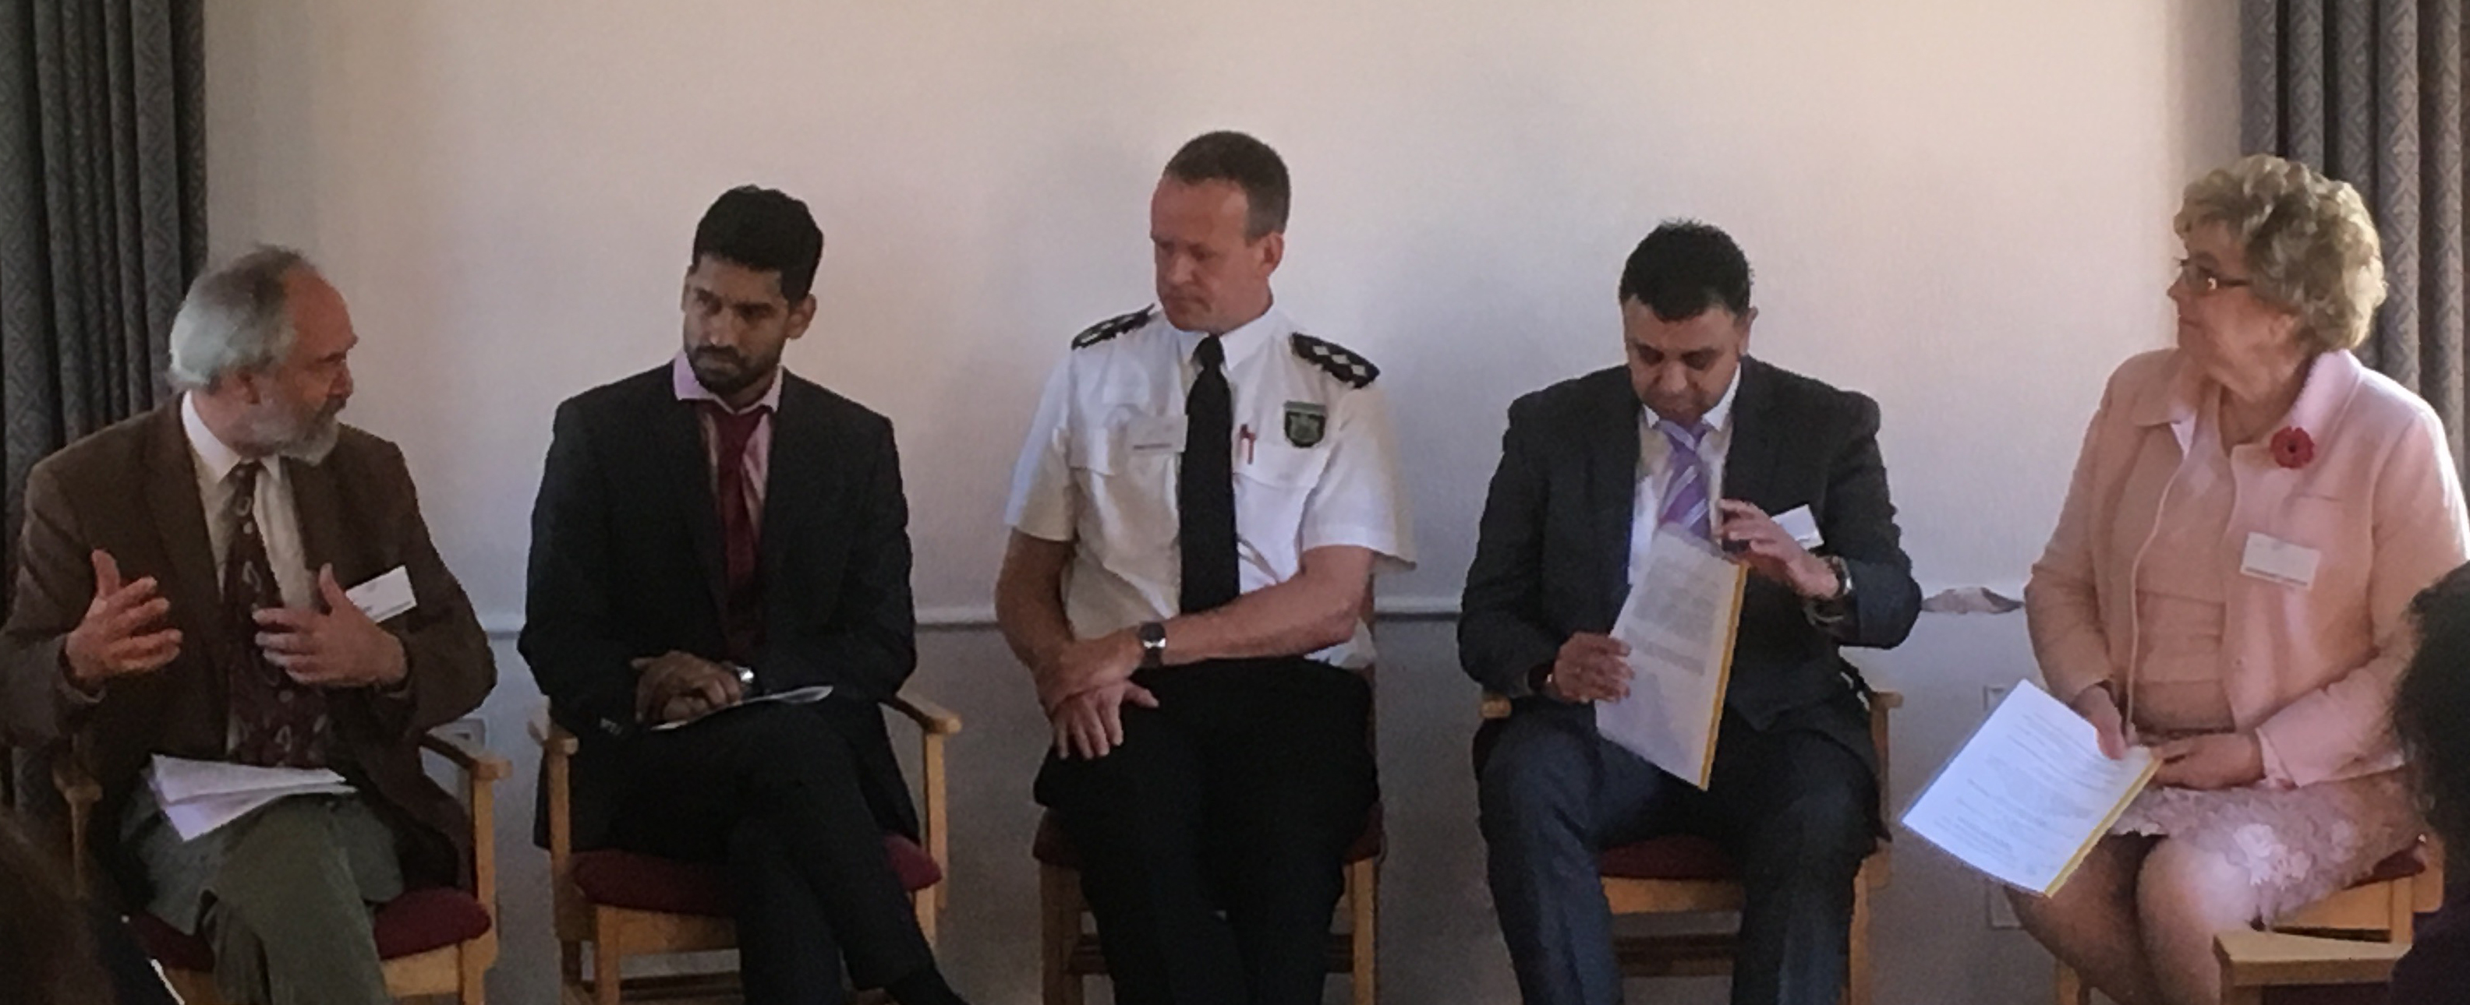
Following a Question and Answer Session, the Conference dissolved for Lunch. While the SEEFF members were having their AGM, the rest of the audience were shown the old library of the college.

Afternoon Session was about Intolerance on the Ground – Individuals and Communities and chaired by Dr Hugh Boulter

The first speaker of the afternoon, Hari Parekh who was formerly of the Hindu faith, now Humanist, talked about apostasy and intolerance. Mentioning that he is currently an assistant psychologist at a low-secure female psychiatric hospital, Hari said that he was the founder and the president of his non-religious society at the University of Northampton. He talked about the difficulties of leaving one’s faith and this driving him into helping those either thinking about leaving religion or who have left their religious faith and need emotional support.

Sarbjit Athwal and Rtd Sgt Clive Driscoll spoke about honour killing. Sarbjit who witnessed honour killing talked about her experiences, when her sister in law was killed by her in laws. Sarb reported this, but due to the lack of evidence, this wasn’t proven for years and during those years she was excommunicated by her Sikh community. Later when Sgt Dricsoll reopened the case and found the evidence. Today both work to raise awareness to honour killing through the charity: True Honour.

Alison Webster, Author of "Found Out, Transgressive faith and sexuality", a long term campaigner for social justice within the Christian community, especially gender and sexual justice, talked about the difficulties people confront when they come out. She said that fundamentalism is putting ideology above humanity. “It’s an abuse to make people fit boxes they don’t fit.”, Alison added. Saying that these people wanted unconditional love rather than conditional on what you do, Alison said some members of the Church still has difficulties to embrace this.

